**( . . . )**

**A Juggling/Motion tracking suite for Max For Live – Version 1**

Created by Gustavo Silveira – 2015

[silveira.go@gmail.com](mailto:silveira.go@gmail.com)

www.bitcontrollers.com

( . . . ) is a group of free Max For Live Devices, dedicated to control Ableton Live, through the movement of juggling balls. Although it’s dedicated to control Live with juggling, it can be used with other objects, since it’s based in a motion tracking system.

( . . . ) has different devices, with distinct functions, and new devices will come in time. In this first version, it comes with a “Motion Tracker”, “Theremizer”, “Melodizer” and “Basser”. Each of them will be described in the chapters bellow.

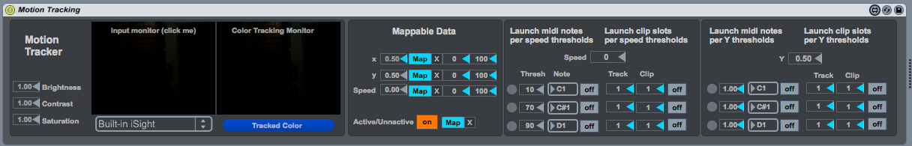**1. MOTION TRACKER**

The Motion Tracker device is responsible for tracking the desired object and transforming it to data, which can be used to map parameters in Live, or to trigger, samples, loops, etc. The device is divided in four parts, which will be described bellow.

**a) Motion Tracking**

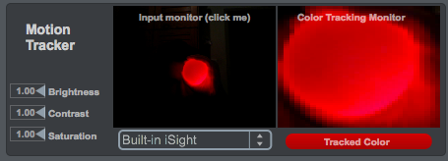

In the Motion Tracking block itself, there are two monitors, an image control, webcam device dropdown menu and a bar with the color that is being tracked. The first monitor is what your camera sees. Click in the object that you want to track and it will be tracked by its color. Its color will be show in the bar and the object will be show in the second monitor. For better adjustments, change the intensity of “brightness”, “contrast” and “saturation".

**b) Mappable Data**

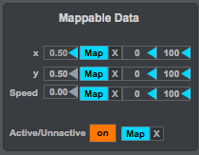

Here, one can see the X and Y position in the screen, which 0 is minimum and 1 and 0 is maximum; the speed of the object, also in the same range; if the object is seeing by the camera or not. Each parameter can be mapped to a lot of parameters in max, such as, knobs, faders and on/off buttons, by pressing the “map” button and, then, pressing the desired parameter that is wished to be mapped.

It is advisable to use the built in M4L device “Multimap”, which allows one to map one parameter to other several parameters in Live.

**c) Launcher (speed)**

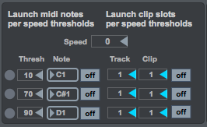

The Launcher is divided in two parts: “Lauch midi notes per speed thresholds” and “Lauch clip slots per speed thresholds”. In this section, one can trigger midi notes ot clip slots when the object reaches a determined speed thresholds. Here, 0 is the minimum speed, but there isn’t a maximum. There is circle that blinks when the threshold is reached; a number box, where one can put the threshold; the midi note that will be trigged, and if it is on or off. This first part will trigger the midi notes, the second one, clip slots, where it can be chosen the clip slot of a specifically track. Note that there are three thresholds that can be chosen, but, the first one acts like “less than” and the other two like “greater than”.

**d) Launcher (Y axis)**

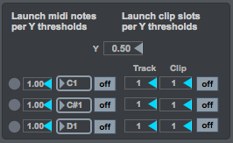

This section works in the same way of the previous one, but it works based on the Y axis. Every time the object reach a certain height, a midi note, or a clip slot can br triggered.

**2. THEREMIZER**

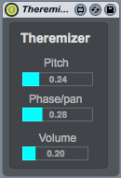

The Theremizer is a Theremin look-alike. It has one controller for its pitch, one for its phase/pan and one for its volume. Map a juggling ball to those values and play it like a juggling ball Theremin.

**3. MELODIZER**

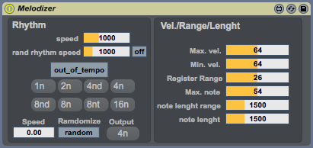

The Melodizer creates melodies based upon the information give in the faders. It creates midi notes, so, it is need to send this notes to a virtual instrument, like a piano, for example. It is random notes generator, and for that to happen, the user needs to press play on Ableton Live. In the first section, the “Rhythm”, one can control the rhythm of the notes. In the button “out_of_tempo / on_tempo” is where it can be chosen if the rhythm is going to work on Ableton’s metronome or not. If it is “out_of_tempo”, it will not sync with the metronome. The first value is the time between each note to be triggered, in milliseconds, so, as smaller is the value, the faster will be the rhythm. Turn the “rand rhythm speed” “on” and it will give the notes random rhythms, where its average speed can be controlled by the fader.

Choose “on_tempo” and it will be in sync with Live’s metronome. Click in the numbers bellow to have different rhythmic divisions. Bellow, one can randomize the rhythm, and use the speed fader in the corner to control the rhythm speed.

In the right it can be controlled velocity, pitch range and length of the notes. Map the ball’s data to different values and take control of this “virtual instrumentalist”.

One tip is putting after the Melodizer the midi effect “scale”, so, only notes in a certain scale will be played.

**4. BASSER**

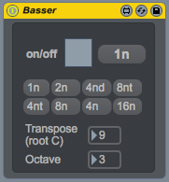

The Basser can be used to create a bass line in your music. It works in a similar way of the Melodizer, but, it generates notes in a minor scale in restrict octave. The rhythm works in Live’s metronome and can be chosen in the buttons. It can be transposed in semitones and in octaves. It is needed to plug a virtual instrument after the Basser, so it can play the midi notes generated by it. There is’t any mappable feature, so, it’s advisable to map parameters of the virtual instrument, like its cuttof, Q, intensity and so on.